# Grouping Topics or Conversations in the Literature Review The “Banquet Hall” Analogy

By Jodie Salter

This handout has an accompanying video on YouTube called Writing the Literature Review: A Banquet Hall Analogy.

## The Selection Process:

Think carefully about who, what, and how much information you need to introduce to your reader because you cannot include everything that you have read in your Literature Review.

Focus on your research question(s) and choose the literature that best helps you to answer different parts of your question.

Sort the literature you read into groups of similar topics, themes, objects, or subjects.

At each “banquet table,” arrange the seating so that authors, theorists, scientists, or studies (of similar topic areas) engage in conversation about their agreements and disagreements in findings, methods, theories, interpretations, etc.

Establish the context of each table conversation within the broad research area to help you and your reader understand why this specific topic area is important to your focused research project. Address historical shifts (methodological, theoretical, political, etc.). Be sure you are familiar with the influential people, canonical studies, and major contributions.

## The Conversations:

For each table, prioritize and introduce first to your reader the key authors or studies in order to establish their significance to the field and their specific influence on your own research.

A Literature Review tends to compare and evaluate literature, grouping similar studies together in an integrated discussion. However, some authors or studies will receive more singular attention and thus page space in your writing. Things you might need to address for an important author or study:

* What are their major contributions to the research field?
* What are the strengths and limitations of their research?
* Who has built upon their research? What is the legacy?
* How does their research contribute to your own analysis or methods?

You cannot introduce everything about an author or study, so focus on the key information that is most relevant to your research project.

Compare and analyze the strengths and limitations of the different studies, theories, methods, etc. (depending on the type of research you do), as well as who agrees and disagrees with each other. Discuss how these table conversations contribute to your own research (i.e., important things you have learned from this literature, your development of new analyses, shifts in your thinking) and demonstrate how this literature helps you answer parts of your research question.

## The Order of Introductions:

Imagine walking your guest (your reader) through the room and explaining each conversation to them. Think about the connections between the “banquet tables” and how you would order the tables to logically develop your research topic.

NOTE: in your discussion section(s), revisit the literature by now adding your own voice and research findings to contribute to specific conversations.

## Planning the Seating Arrangement

The following image is designed to help you begin to visually organize who you will sit together in conversation around a specific topic or theme. Depending on the length of your paper and complexity of your research, you may require more than three tables.

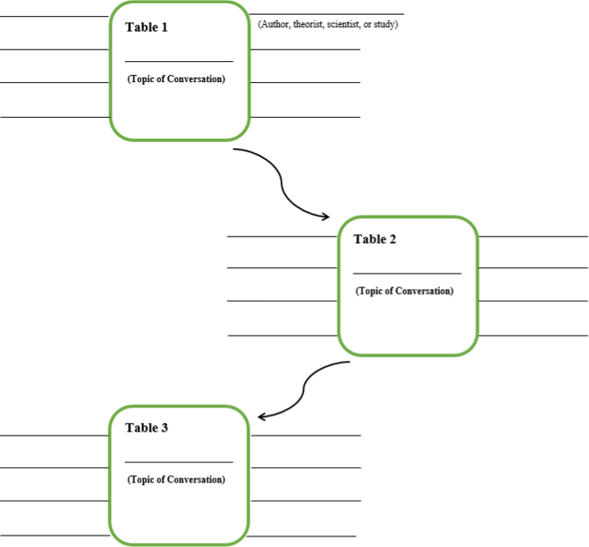

## Banquet Hall Table – Note-taking Sheets

What is the topic and context of this specific table conversation?

### GUEST #1: Who is the most important person at this table?

Title (of article or study) and name of author/authors

What are the contributions, strengths/limitations, and/or relevance of Guest #1 to your research question?

### GUEST #2: Who is the second most important person at this table?

Title (of article or study) and name of author/authors

What are the contributions, strengths/limitations, and/or relevance of Guest #2 to your research question?

How does GUEST #2’s research relate to GUEST #1?

### GUEST #3: Title (of article or study) and name of author/authors

What are the contributions, strengths/limitations, and/or relevance of Guest #3 to your research question?

How does GUEST #3’s research relate to the other guests?

### GUEST #4: Title (of article or study) and name of author/authors

What are the contributions, strengths/limitations, and/or relevance of Guest #4 to your research question?

How does GUEST #4’s research relate to the other guests?

### ADDITIONAL GUESTS: Who are the other guests to be included at this table? Why?

### What is the significance of this table to your Research Question?